Terrain Driving Tips

Off Chamber
Turn down hill if you need to get out of an off-camber situation.  An "off-camber" situation is one where your vehicle is sideways along a slope. In an off-camber situation, your vehicle is pointing neither straight up or down the hill. Try to avoid off-camber situations at all times, because being off-camber can lead to tipping or rolling over. | 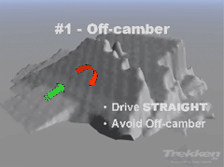

Uphill
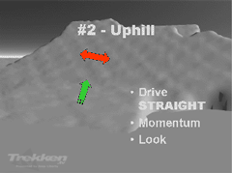 | Know what's at the top before starting up.  Always drive straight when going up or down hills. Going straight gives you the most traction to get up the hill, and keeps your vehicle from sliding sideways or tipping over.

Downhill
Know what's at the bottom before you start down.  Always drive straight when going up or down hills, and select a low gear (such as 1st or 2nd) before starting down. Using a low gear allows the engine to do most of the breaking and gives you greater control. If you're still going uncomfortably fast, use your brakes lightly to slow down. | 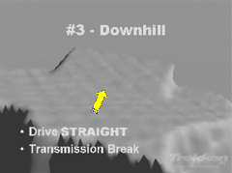

Crossing Logs
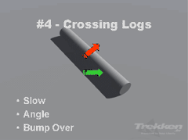 | Watch front and rear overhangs on vehicle.  An exception to the "always drive straight" rule, logs are best crossed at an angle. Crossing small but straight obstacles (like logs) at an angle makes one tire go over the obstacle at a time. Since only one tire is going over the obstacle, the other three tires are on the ground providing traction.

Crossing Ditches
Watch front and rear overhangs on vehicle.  You can think of crossing ditches much like crossing logs, except that the obstacle in this case is in the ground instead of on top of it. Like logs, ditches are best crossed at an angle with only one tire at a time. This leaves the other three tires on the ground to provide traction. Use moderate momentum if necessary. | 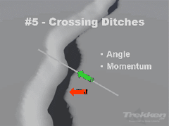

On Rocks
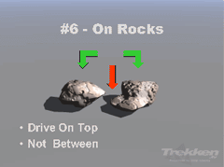 | Watch front and rear overhangs on vehicle.  Think of rocks as your friends: drive on top of rocks instead of avoiding them.  Driving on top of rocks lifts your vehicle up and keeps the softest part of your vehicle-- the tires-- right where they should be to get the most traction. Lowering your tire air pressure by 10 or 15psi will soften your ride and give you less bounce, thereby increasing your traction.

Through Mud
Check mud for hidden rocks and other obstacles.  Keep two things in mind when driving through mud-- drive straight, and keep up your momentum. Don't give up if you feel you're getting stuck. Instead, keep driving to help clear your tires of the mud build-up. Of course, you'll want to check the depth of the mud and where you can exit to make sure you can get out before you get in. | 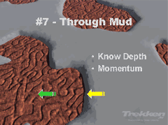

Crossing Streams
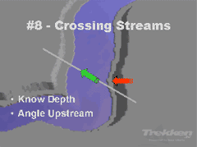 | Don't attempt to cross fast moving streams.  Like mud, you'll want to check both the water depth and exit for streams to make sure you can get out before you get in. However, unlike mud, cross streams at an upstream angle. Crossing upstream gives you the most control.

Over Sand
Fix a high flag to your vehicle to make sure you're seen.  It's very important to lower your tire air pressure, sometimes as low as 15psi, before venturing out into sand. And always keep your momentum while driving-- coming to a complete stop will often get you stuck. | 